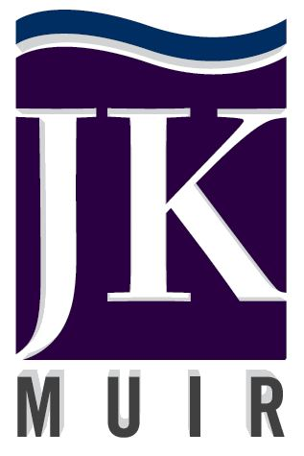

COMPANY OVERVIEW
Founded in 2008, by Jen Muir, JKMuir is a versatile, innovative environmental engineering and energy consulting firm specializing in equipment commissioning and energy efficiency. JKMuir offers a broad range of engineering capabilities and technical services to construction and engineering firms, including feasibility studies, planning, design, construction inspection and commissioning assistance. JKMuir also specializes in project funding, and connects construction projects of all types with the funding and grant assistance available through utility and state efficiency and renewable energy programs.
Certifications

DOT DBE – CT, MA, RI, NY
WBE – CT, MA, RI, NJ, NY, NYC,
CA, OR
Contact Person

Jen Muir, Owner/President
2275 Silas Deane Highway
Rocky Hill, CT 06067
Work Phone: 860.249.0989 x700
Cell Phone: 860.367.3570
E-mail: JenMuir@jkmuir.com

www.jkmuir.com

CORE SERVICES
- Commissioning & Start-up Services
- Construction oversight & inspection
- Energy Efficiency Project Funding & Applications
- Quality Control & Quality Assurance Services
- Renewable Energy Technologies Evaluation
- Sustainable Design Alternatives
- Water & Wastewater System Design
- Construction Administration Assistance

DIFFERENTIATORS
- Staff includes licensed Professional Engineers – Environmental, Mechanical, & Civil.
- Experience in project QA/QC requirements & documentation.
- Specialize in water, wastewater, and industrial process system.
- Field testing equipment for detailed assessments, commissioning, and measurement and verification.
- Experience with project funding associated with energy efficiency and on-site generation.
- Experience with municipalities and private sector facilities and clients.

PAST PERFORMANCE
- Connecticut Department of Transportation – JKMuir has provided assistance during the commissioning of the New Haven and West Haven Railway Station Construction, and Bus Maintenance Facility including oversight of the start-up and commissioning of lighting, HVAC and controls, and building system automation and instrumentation.
- Technical Assistance Engineering Services Provider, Eversource, Ongoing – JKMuir provides energy analysis assistance, energy savings validation, energy audits and focused studies, pre/post installation inspections, training and presentations; and technical and engineering services related to the evaluation, planning, design, project management, and commissioning of energy conservation projects for Eversource.
- New York City’s Mayor’s Office of Sustainability (MOS), NYC 80 X 50 – JKMuir is working to develop strategies for drastic reduction of waste related greenhouse gas (GHG) emissions to meet the City’s commitment to 80% GHG reduction by 2050. Scope includes GHG model, on-site generation options for organics utilizing, and wastewater facility resource recovery.

