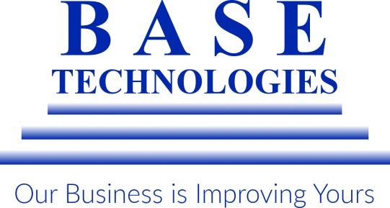

23 FRANCIS J. CLARKE CIRCLE
BETHEL, CT 06801-0542
800-466-6377
BASEINC.COM
Who we are:
In the early 90’s, Fujitsu discontinued their facsimile business leaving hundreds of office technology professionals without work. In 1992, two former employees put their years of experience to use by starting a company named BASE Technologies. Headquartered out of our president’s living room, the duo found success early by providing high-end office products with a personalized level of service. As time went by, their success continued and BASE transformed from a company that focused primarily on hardware, to a solution-driven business. Today, over 25 years later, BASE focuses on providing managed print services and document solutions with the ultimate goal of improving our client’s day-to-day workflows, leading us to develop the slogan "Our Business is Improving Yours".
Today, BASE Technologies focuses on doing business both in the state of Connecticut and nationwide. We currently offer the following:

Printing Systems

Managed Print

Document Management

Mission Statement
To provide quality products, service and solutions that will surpass the expectations of our customers. To sustain a work-friendly atmosphere which allows for open communication, respect for the individual and recognition of dedication and effort; all of which contribute not only to future success, but to quality of life.
Why BASE:
For more than 25 years, BASE Technologies has provided outstanding office products and services to customers both in Connecticut and nationwide. As our positive testimonials will show, we take pride in providing our clients with:

Cutting-Edge Technology

Excellent Communication and Collaboration

Unparalleled Service
Originally formed in 1992 as a result of Fujitsu leaving the North America facsimile market, BASE Technologies has formed strong partnerships with Kyocera, HP, Xerox and other superior technology manufacturers. This allows us to offer a range of first-rate copiers, laser printers, and document management solutions to our customers. BASE Technologies has annually received awards for best in the class service, outstanding customer service, most Elite Kyocera / Copystar dealer. Our service department provides weekly reports on the following to assure our customers are being provided the best service possible. Daily, weekly and monthly reports are issued along with customer surveys after each service call is our standard here at BASE. The below helps maintain the high service ratings and customer retention rating as our Technicians are graded based on the below requirements. Goals are set, and each Technician is responsible to achieve those goals.

Response Time

First Call Completion

Preventative Maintenance

BASE Technologies provides overall solutions to organizations of many different types and sizes. Our main goal is to partner with our customers to provide them with the best solution for their printing, document and workflow needs. Not all organizations have the same needs, workflow and operational standards in place, which means when looking for a vendor to handle their printing requirements a partnership needs to be inquired. This is where BASE excels and becomes a leading provider in overall solutions that are tailored to each individual organization and entity. Our past experience allows us to provide the knowledge and expertise that is needed to maintain service and manage an organizations printing environment. At BASE we take pride in providing our customers with the following business benefits.
Reduce Expenses
Sustainability
Streamline Processes
Secure Information
Compliance

With implementation of the solution that best fits the needs of our customers; we manage and maintain the account by looking at the following throughout the term of contract.
Print Accountability
Printer Management
Right – Size of Equipment
Workflow Optimization
Rules based printing suggestions

BASE Technologies is an award winning service provider that supplies the latest and best in the class technology throughout Connecticut and Nationwide to our customers. We are a Total Solutions provider that excels in meeting all types of organizations requirements. Our programs are tailored, and we excel within the Non-Profit, Healthcare, Education and Financial market place.

Please see the below references that have experienced the services we provide:

Optimus Health Care

Cornell Scott Hill Health

Bethel Public School District

Union Savings Bank

People’s United Bank

