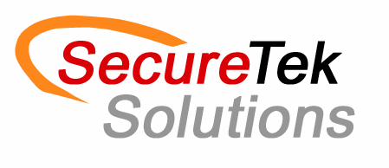

**Core Competencies:**

Providing project based staffing solutions

* Temporary skill sets provided

Construction Management  
- Project Managers

* Assistant Project Managers
* Project Engineers
* Superintendent
* Health & Safety Professionals
* Quality Control
* Project administration

Skilled Trades

* Plumbers, Welders, Electricians, Sheet Metal techs
* Pipefitters, Carpenters, Equipment Operators,

**Capabilities Statement**

**NAICS:**  
561320 541340  
541330 541340  
561312 561311

**DUNS:**  
031512923

**CAGE:**  
7EQU0

**Corporate Contact:**  
*Javon Overstreet*  
(860) 760-0313 x. 301  
Javon@secureteksolutions.com

**Business Development Contact:**  
*Zachary Herrick*  
(860) 760-0313 x. 302  
Zach@secureteksolutions.com

**Website:**  
www.secureteksolutions.com

**Past Performance Sampling:**  
  
- MDC – Wet Weather Expansion  
- Camp Hartell – Mechanical Upgrades  
- The Hartford – Mechanical Upgrades  
- Springdale Elementary School – Lighting Retrofit   
- City of Hartford – Highest

Priority Pump Station

**Company Profile:**  
  
SecureTek Solutions, LLC is a Minority-Owned Small Business providing Engineering and Construction recruiting services in the Aerospace / Defense, Energy, Environmental, Construction and Architecture industries.

We work with Clients in Pre-Award Teaming partnerships or on a Post-Award basis to deliver technical and non-technical services to support our partners in delivering to their end customer.

**Client Sampling:**  
  
- Delray Contracting  
- Carlin Contracting   
- New England Mechanical Services   
- Modern Mechanical Systems  
- O&G Industries  
- United Illuminating   
- Woodard & Curran